The O2 Belfast (arena)
Venue Access Information

Welcome to the venue access information for The O2 Belfast. The O2 Belfast is an inclusive venue and is committed to ensuring that services are accessible to all visitors. The arena is delighted to be signed up to the Attitude is Everything Charter of Best Practice. Please contact us if you have any comments that would help us improve our service.

The O2 Belfast (arena) offers:
- Disabled parking spaces
- Accessible toilets
- Changing Places toilet
- Accessible lifts
- Wheelchair spaces
- *Box Office, Concierge Desk and catering units with low level counters
- *Box Office with induction loop (event nights only)
- Accessible viewing platforms
- FM hearing loop system within the arena bowl
- Storage of walker or other equipment
- Assistance dogs welcomed
- Sensory bags with ear defenders, fidget toy, lap pad, visual cue card and wobble cushion
- Essential Companion at reduced or no additional cost (subject to availability)

*Box Office opens 1 hour before door opening time on event days only.

Purchasing Tickets

The O2 Belfast use www.Ticketmaster.ie as the principal way to purchase tickets for events at the Arena.

Wheelchair tickets
Tickets within the wheelchair areas can be purchased online at ticketmaster.ie, and tickets for other access requests, such as for visual or hearing impaired customers, can be seen by clicking the accessible (♿️) symbol on the individual event page, below the title on Ticketmaster.

Other accessible requirements
Each event webpage has an “accessible tickets” button that will provide specific information for the types of tickets that can be purchased.

Please select the 'All Ticket Types' button and read the relevant description of those tickets and choose the correct one for your access requirement. Select Wheelchair Accessible, Ambulant, Sight Impaired or Hearing Impaired as appropriate from the drop-down menu.

Ticketmaster has visual symbols explaining the different accessible ticket types. Please select the relevant ticket type from the interactive map or the drop down menu.

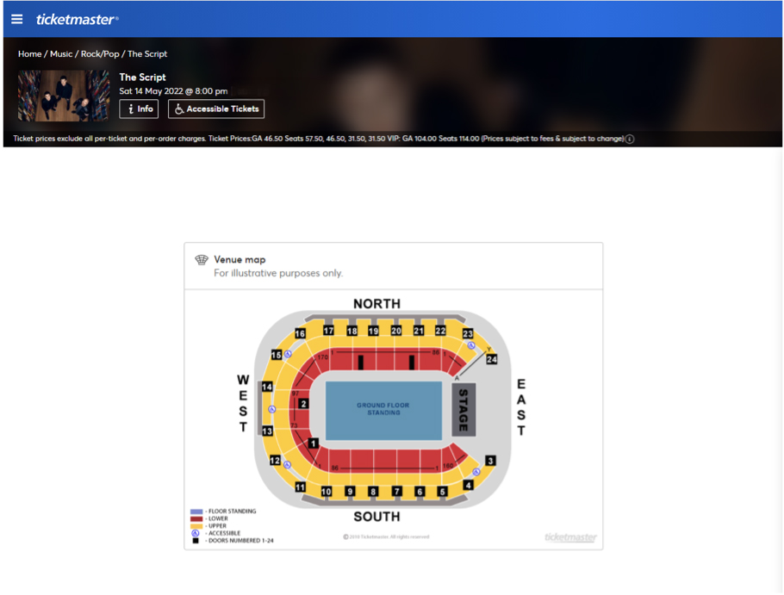

On an event night, The arena Box Office is open from 1 hour before doors for ticket collection/queries. It has a low level counter and an accessible ramp to the window area. Hearing enhancement systems are also available at the Box Office counter.

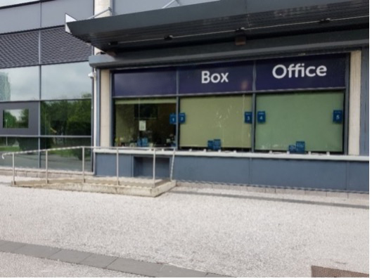
Box Office counter

Essential Companion tickets

The promoter may offer a limited number of concession tickets to ‘essential companions’ where the person they are caring for would not be able to attend for the duration of an event without the aid of someone to assist. This concession will allow an essential companion to attend either at a reduced fee or at no additional cost, depending on the event.

By accepting a ticket, the essential companion assumes responsibility for tending to the personal needs of the person they are accompanying. They must also agree to remain with the disabled person throughout the performance and assist them in the case of an emergency situation arising. Arena event staff members cannot assist with toileting arrangements. All requests for assistance in toileting shall be referred to the event medical staff.

In order to issue Essential Companion tickets, the customer will be asked to provide proof of eligibility by one of the means listed below:

- Front page of DLA (Medium or Higher rate)
- Front page of Attendance Allowance letter (no specific rate required)
- Front page of PIP (no specific rate required)
- Evidence that registered severely sight impaired (blind)
- Recognised Assistance Dog ID card

(Customers can blackout any information that relates to amount of benefit paid or health conditions etc. that might be on any documents submitted)

This information should be uploaded onto the customer’s Ticketmaster account.

Accessible Areas

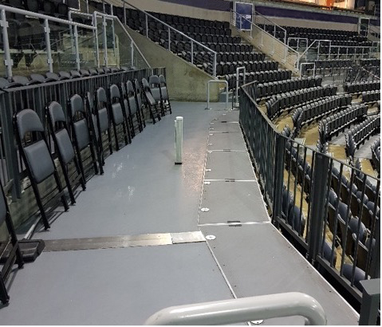
Accessibility platform

We have a total of 34 spaces available for wheelchair users; there are 22 in the West tiered seating and 12 in the East tiered seating. The precise number of areas for visitors using wheelchairs will depend on the format of the event, as not all will be available or use. If it is a seated show, generally there will be up to 8 additional wheelchair spaces within the floor seating area. There are charging points for electric wheelchairs at some of the accessible areas – if you need this facility please use the Contact Us section of The O2 Belfast Website.

In general, tickets in the wheelchair area can be reserved for a wheelchair user and 1 companion, to ensure availability for other wheelchair users. We will endeavour to ensure that other customers in the party are seated close by, but this is not always possible if it is a fast-selling show.

Wheelchairs are not permitted on the floor area during standing shows.
The reasons for this are:
- Lateral crowd movement and crowd dynamics may lead to the wheelchair being overturned causing possible injury to the disabled customer or another member of the audience.
- An unknown quantity of wheelchairs within an area may inhibit the exit times through the emergency exits during an evacuation.

Wheelchairs can also access the 2nd floor suite level, but please advise at time of booking a suite that you require wheelchair access, as adjustments may need to be made in advance.

Unfortunately, it is not reasonably practicable for wheelchair users to be accommodated in seating blocks outside of the designated areas. If you purchase a ticket for another area, we will endeavour to accommodate you within a designated area but may not always be possible.

If you need a wheelchair and have your own, please bring it with you. We only have a very limited number of manual wheelchairs available for hire free of charge. We strongly advise visitors to pre-book wheelchairs via the Contact Us section of our website, or ask a member of staff on arrival. Our wheelchairs will be given on a first come, first served basis.

Access to performance
Visual & Hearing Impairments
We have a small amount of tickets available in the tiered seating or floor seating area (seated shows only) for customers with a sensory impairment. These tickets will be held for a period of 14 days from on sale, and if you would like to avail of these seats please contact us here.

A hearing loop system is operational in the auditorium for all events and is operational with hearing aids on ‘T’ setting or a neck loop can be provided. Customers wishing to utilise this system should inform Ticketmaster Customer Services when purchasing tickets or speak to the concierge desk on the event night. There is also a hearing loop system at the Box Office counter.
On Belfast Giants games, we provide Audio Description Commentary of the play. Customers can collect a hearing loop pack from Concierge Desk on an event night.

We do not currently provide mobile connect systems, captioning, audio description and relaxed performances as standard, however we are happy to discuss with touring productions in case they can facilitate any of the above.

Communication/interpretation of show content
Customers are advised to make any requests for additional methods of communicating the performance content i.e. by sign language interpreters, audio description etc. via the Contact Us section of The O2 Belfast website.

Seats are held in possible suitable areas for a period of 14 days from on sale, and the Arena will work with the promoter and production to try to make accommodations on a show by show basis, but this is largely dependant on the production of the show.

Once this 14 day period has passed, these seats may be released to general public if there is high demand for tickets. After this stage, any request will be considered, however the location will be assessed on an individual basis. Any request made within 28 days of an event may not be granted.

Assistance animals
Assistance animals are welcome, but visitors are asked to bear in mind the noise levels at concerts and the potential use of special effects including pyrotechnics and strobe lighting.

Seated Areas
Visitors who wish to keep their assistance animal with them during the show must use the designated wheelchair areas as these provide the safest locations. Assistance animals are not permitted in the general seating areas during concerts.

If requested, the arena staff will ensure the animal is cared for in a quiet area in the foyer and will return it to its owner when leaving.

Standing Areas
Assistance animals are not permitted on the floor area during standing concerts. If requested the arena staff will ensure the animal is cared for in a quiet area in the Foyer and return it to its owner when leaving the floor area. A complimentary ticket can be issued to an Essential Aid who will assume responsibility for assisting the disabled person whist they are on the standing floor area.

Sensory needs

Customers with Autism or other sensory processing needs can request a sensory bag. These bags contain ear defenders, fidget toys, weighted lap pad, wobble cushion and cue cards. There are a limited number, and a deposit scheme will be in place at the concierge desk.

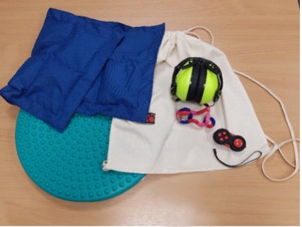

We will endeavour to facilitate a request for a quiet room, however given the nature of sound levels at events, and room availability, this will be assessed on an event by event basis.

We can facilitate a visit to the venue on a day when there is no event, if you think it would be helpful to familiarise yourself with the building before you attend an event, however this will be dependant on a suitable day.

Please use the Contact Us section of the website to submit your request.

Travel Guide

Drop-Offs
Customers with disabilities can be dropped off at the roadside at the South VIP Entrance of the arena. It is recommended that drop-offs are done so in as quick a manner as possible. Please refrain from parking on double yellow lines or blocking entries and roadways.

Parking
Disabled parking bays are available in the main car park. The car park operates on a first come first served basis for all parking spaces. Blue badge holders must display their blue badges at all times whilst parked.

Taxis
Taxis can drop off at the side of the road beside the water edge. The turning circle is closed for taxis and other vehicles during events.

Buses
Translink's Metro Service Number 94, 94a & 94b leaves Belfast City Centre at Donegall Square West and makes a stop outside The O2 Belfast.

The Glider G2 service is operational from the front of the arena that goes into the City Centre, or towards Titanic. This service operates on a loop and customers can change at City Hall for the G1 that operates across Belfast.

General Access
Entry into the arena is at street level, lifts are available to provide access to all levels of the building. Vertical access through the building is provided principally by three lifts, one located in the North VIP entrance, one in the South VIP entrance and one in the main entrance lobby. Staff are on hand at events to provide assistance if requested.

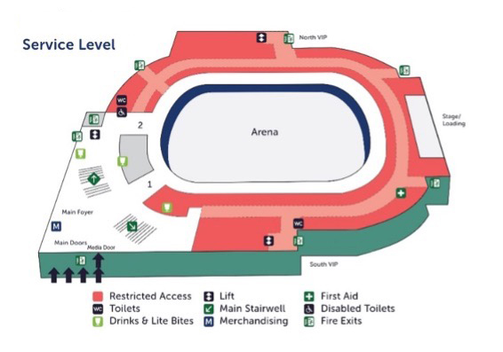
Map of Arena

Arriving at the Venue

All entry doors into the venue are kept in the open position for entry when events are taking place, unless there are high winds when they may be kept closed for safety reasons but manned by a member of staff. The clear door opening width of all entry doors is 1900mm.

There are three entrances into the venue, the main entrance at the front of the arena, and through the Odyssey Pavilion on the ground and first floor. Generally all entrances are open, but occasionally, depending on the event, people may be directed to enter via a specific entrance (eg. floor customers on a standing show entering via ground floor pavilion). Customers will be communicated to on an event-by-event basis in advance, and staff will be on hand during the event to direct people.

There is step-free access via the front doors of the venue into the main foyer. The floor surfaces are all smooth and level, and the lighting levels are good.

There are also 2x VIP entrances which are located at the South side of the building (front beside Box Office) and at the North side of the building (around the back). Both entrances are step free, floor surfaces are smooth and level, lighting levels are good and they both have lift access to all floors.

Early Entrance

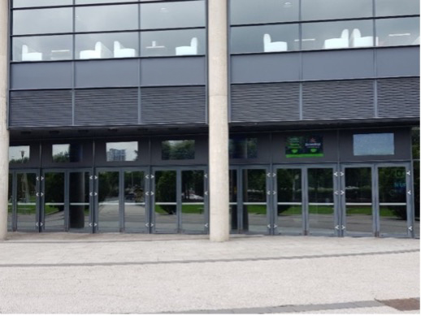
Main entrance

If you cannot queue, or need early access into the venue before the advertised door opening times, we will do all we possibly can to help, and will arrange for seating to be made available if required. Although we are not able to offer early admission to the auditorium itself, we could arrange for you to access the foyer area, or the VIP entrance so that you can avoid any long queues, especially for standing concerts.

Generally we recommend that anyone with access requirements enters via the VIP/Access Door (on the right in the picture above) as it is quieter and there are limited queues.

Please speak to a member of staff on arrival to explain your requirement.

Signage

The O2 Belfast is committed to providing inclusive signage that is easy to understand and with as much visibility as possible.

Directional signage, and signage for seating blocks is provided in clear text with white characters on a blue background. For maximum visibility when the concourse is busy with visitors, all signage (where practicable) has been provided above head height.
- Toilet signs have white figures on a black background
- Accessible toilets have white symbols on a green background
- Changing places toilet has signage approved by Muscular Dystrophy UK
- Braille enhanced signage is provided within lift cars and signage external to lifts.

Food, Beverage and Merchandise Sale Points

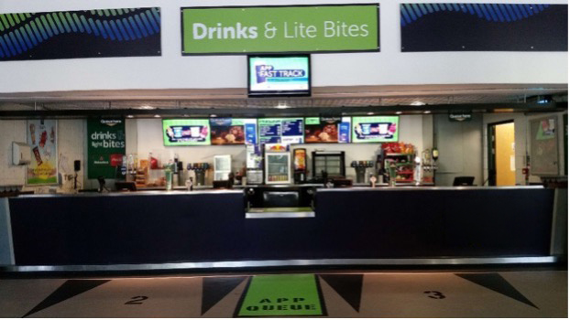
Catering units

• All food, drink and merchandise areas have level access
• There are low level counters at all locations
• Dietary needs can be catered for
• All areas are well lit and the floors are level and anti-slip
• There are accessible toilets close to all the Food & Drink areas

Toilets
There are 10 accessible toilets throughout the front of house areas in the arena.
The Ground Floor is equipped with a male and female accessible toilet outside Door 2 in the main foyer.

The Concourse Level is equipped with unisex accessible toilets at Door 4, 12 and 23. The Sky Lounge is also equipped with unisex accessible toilets.

The North, South and West Suite Levels all have a unisex accessible toilet also.

Changing Places Toilet
A Changing Places toilet is available in the Arena. It is located on the first floor concourse at Door 15. This room is normally locked - if you need access, we ask that you tell us in advance if you are coming to an event at the arena by using the Contact Us section of the website to tell us.

Once in the building, a key is kept with Concierge desk or staff in the area of the Changing Places. Please speak to a member of staff who can assist you.
Please note that the Arena does not provide slings for us with the ceiling hoist for hygiene reasons - customers are requested to bring their own.
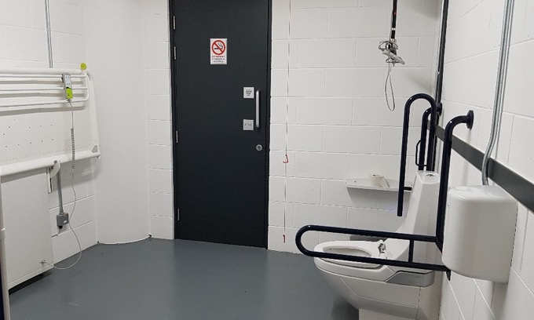

Customers with Medical Requirements
The O2 Belfast has a strict no food or drink policy in terms of items brought into the venue. However, we do welcome visitors who need to bring medicines, food or drink to manage a medical condition. To ensure we know about your needs we encourage customers to inform us in advance of events.

There is a Medical Room on both the ground floor and first floor of the Arena. Qualified medical staff are on duty when the Arena is open to the public at all times.
In the event of a medical emergency, please notify a steward who will radio for medical assistance.

Should you require a private area for personal care (eg. private changing facilities / medicine storage or refrigeration) please speak to the staff at the Concierge Desk who should be able to assist you.

Show content
Sound Levels
We have little influence in the running of live music events when it comes to sound levels. Artists generally travel with their own sound and lighting systems and their engineers control them throughout the event. We do monitor both sound quality and decibel output and we will advise production crews when necessary, although we will not be able to turn the volume down unless it is breaching legal limits. Ear plugs are available on request from the nearest steward or from the Concierge Desk. N.B. We are unable to provide sound cancelling ear protection for young children and babies.

Special Effects (Strobe/Pyro/Lasers etc.)
Strobe lighting, pyro and lasers may be used during some performances and may not be communicated to the Arena until the day of the event. Customers will be notified in advance (most commonly via signage around the Arena) if a performance includes the use of any of these.

Feedback
Any customer service correspondence should be sent to us by post, or visit the Contact Us section of the website to provide as much detail as possible to enable us to fully investigate your enquiry.

If posting your enquiry please send to: Customer Services, The O2 Belfast, 2 Queen's Quay, Belfast, BT3 9QQ
In order for us to assist you more efficiently please provide us with the following information
1) Name of event and date
2) Full contact details
3) Seat location - row and seat number
All complaints will receive a letter/email of acknowledgement, with an aim to investigate and reply to the complaint within 10 working days.

